Supplementary files

Table A1: Logit regression on employment for men and for women
 | MEN | WOMEN
 | Employment | Employment
Age | -0.02 | 0.03**
 | (0.01) | (0.01)
Age squared | -0.00 | -0.00**
 | (0.00) | (0.00)
Years of education | 0.10*** | 0.18***
 | (0.03) | (0.02)
Lives in big or medium city (0= lives in town or rural area) | -0.10 | -0.06
 | (0.21) | (0.15)
Region (Ref. north/est)
West | 0.57* | 0.34*
 | (0.23) | (0.16)
South | 0.12 | 0.15
 | (0.22) | (0.16)
Lives with partner (0=lives alone) | 1.55*** | 0.52***
 | (0.23) | (0.15)
Kids under age 12 in household (0=no) | 0.18 | -0.81***
 | (0.25) | (0.14)
Fluent Dutch (0= not fluent Dutch) | 0.40 | 0.85***
 | (0.23) | (0.18)
Dutch citizenship (0= foreign citizenship) | 0.01 | -0.67**
 | (0.26) | (0.21)
Origin group (0=Native Dutch majority)
1st gen Moroccan | -1.39*** | -1.11***
 | (0.34) | (0.23)
2nd gen Moroccan | -1.24*** | -0.91***
 | (0.33) | (0.24)
1st gen Turk | -1.05** | -0.91***
 | (0.35) | (0.24)
2nd gen Turk | -1.16*** | -0.65*
 | (0.31) | (0.26)
1st & 2nd gen Non-Western | -0.94* | -0.51
 | (0.39) | (0.35)
1st & 2nd gen Western | -0.34 | -0.78*
 | (0.51) | (0.34)
Constant | -1.28* | -1.42**
 | (0.56) | (0.45)
N | 1828.00 | 2105.00
ll | -580.35 | -822.41
chi2 | 167.57 | 379.83
Standard errors in parentheses. * p < 0.05, ** p < .01, *** p < .001

Table A2: Logit regressions on overeducation for men and women
 | MEN |  | WOMEN
 | Mean measure | Mode measure | Mode measure | Mode measure
Age | -0.04 | -0.02 | -0.01 | 0.02
 | (0.03) | (0.02) | (0.03) | (0.02)
Age squared | 0.00 | 0.00 | -0.00 | -0.00
 | (0.00) | (0.00) | (0.00) | (0.00)
Years of education | 1.68*** | 1.28*** | 1.58*** | 1.42***
 | (0.17) | (0.09) | (0.11) | (0.08)
Lives in big or medium city (0= lives in town or rural area) | -0.05 | -0.38 | -0.56* | -0.45*
 | (0.34) | (0.20) | (0.28) | (0.21)
Region (Ref. north/est)
West | 0.61 | -0.17 | 0.09 | 0.03
 | (0.38) | (0.23) | (0.32) | (0.23)
South | 0.69 | 0.20 | 0.48 | 0.14
 | (0.39) | (0.24) | (0.32) | (0.23)
Lives with partner (0=lives alone) | -0.48 | -0.02 | -0.05 | -0.37
 | (0.35) | (0.23) | (0.32) | (0.24)
Kids under age 12 in household (0=no) | -0.39 | -0.06 | -0.05 | -0.01
 | (0.36) | (0.22) | (0.31) | (0.22)
Fluent Dutch (0= not fluent Dutch) | -0.68 | -0.78* | -0.65 | -0.47
 | (0.42) | (0.30) | (0.67) | (0.46)
Dutch citizenship (0= foreign citizenship) | 0.94 | 0.61 | 0.10 | 0.48
 | (0.52) | (0.34) | (0.69) | (0.52)
Origin group (0=Native Dutch majority)
1st gen Moroccan | 1.08* | 1.05** | 0.02 | 1.14*
 | (0.51) | (0.37) | (0.59) | (0.48)
2nd gen Moroccan | -1.71* | 0.78* | -0.62 | 0.31
 | (0.85) | (0.38) | (0.61) | (0.39)
1st gen Turk | 0.46 | 0.91* | -0.03 | 0.95
 | (0.57) | (0.36) | (0.79) | (0.54)
2nd gen Turk | 0.48 | 0.85* | -0.32 | 0.16
 | (0.56) | (0.38) | (0.66) | (0.44)
1st & 2nd gen Non-Western | -0.23 | 0.12 | -1.01 | -0.29
 | (0.77) | (0.49) | (1.33) | (0.53)
1st & 2nd gen Western | -1.52 | -0.06 | 0.08 | 1.45**
 | (0.78) | (0.44) | (0.61) | (0.56)
Constant | -24.09*** | -16.99*** | -22.76*** | -18.79***
 | (2.22) | (1.16) | (1.68) | (1.28)
N | 1591.00 | 1591.00 | 1542.00 | 1542.00
Standard errors in parentheses. * p < 0.05, ** p < .01, *** p < .001

Table A3: Logit regressions on undereducation for men and women
 | MEN |  | WOMEN
 | Mean measure | Mode measure | Mode measure | Mode measure
Age | 0.00 | 0.02 | 0.03 | -0.02
 | (0.02) | (0.01) | (0.02) | (0.01)
Age squared | -0.00 | -0.00 | -0.00* | -0.00
 | (0.00) | (0.00) | (0.00) | (0.00)
Years of education | -1.42*** | -1.70*** | -0.98*** | -1.50***
 | (0.10) | (0.10) | (0.10) | (0.08)
Lives in big or medium city (0= lives in town or rural area) | 0.99*** | 0.45 | -0.01 | 0.28
 | (0.29) | (0.24) | (0.23) | (0.21)
Region (Ref. north/est)
West | 0.23 | 0.04 | 0.66* | 0.19
 | (0.34) | (0.25) | (0.30) | (0.26)
South | 0.04 | -0.24 | 0.14 | -0.09
 | (0.37) | (0.25) | (0.33) | (0.27)
Lives with partner (0=lives alone) | 0.97* | 0.30 | -0.35 | 0.17
 | (0.39) | (0.28) | (0.28) | (0.24)
Kids under age 12 in household (0=no) | -0.74* | -0.36 | -0.08 | -0.34
 | (0.34) | (0.26) | (0.27) | (0.22)
Fluent Dutch (0= not fluent Dutch) | 0.53 | 1.23*** | 1.46* | 0.84
 | (0.40) | (0.32) | (0.70) | (0.46)
Dutch citizenship (0= foreign citizenship) | -0.94 | -0.96** | -1.48 | 0.09
 | (0.56) | (0.35) | (0.87) | (0.56)
Origin group (0=Native Dutch majority)
1st gen Moroccan | -1.53** | 0.35 | 0.27 | -0.21
 | (0.57) | (0.37) | (0.49) | (0.39)
2nd gen Moroccan | -1.06 | -0.29 | 0.56 | 0.08
 | (0.75) | (0.46) | (0.44) | (0.41)
1st gen Turk | -1.14* | 0.18 | 0.29 | 0.04
 | (0.57) | (0.40) | (0.55) | (0.47)
2nd gen Turk | 0.08 | -0.43 | 0.47 | -0.10
 | (0.51) | (0.38) | (0.43) | (0.44)
1st & 2nd gen Non-Western | -1.51* | -0.41 | 0.12 | 0.03
 | (0.61) | (0.51) | (0.77) | (0.42)
1st & 2nd gen Western | 0.67 | -0.26 | 0.14 | -0.30
 | (0.58) | (0.64) | (0.65) | (0.39)
 | 10.65*** | 16.67*** | 7.72*** | 15.15***
Constant | (1.24) | (1.12) | (1.13) | (1.11)
N | 1591.00 | 1591.00 | 1542.00 | 1542.00
Standard errors in parentheses
* p < 0.05, ** p < .01, *** p < .001

Table A4: Logit regressions on undereducation for men and women
 | MEN |  |  | WOMEN
 | Labor force participation | Employment (excl. inactive) | Employment (incl. inactive) | Labor force participation | Employment (excl. inactive) | Employment (incl. inactive)
Age | -0.02 | -0.00 | -0.02 | 0.01 | 0.04** | 0.03**
 | (0.02) | (0.02) | (0.01) | (0.01) | (0.02) | (0.01)
Age squared | -0.00 | -0.00 | -0.00 | -0.00* | -0.00 | -0.00**
 | (0.00) | (0.00) | (0.00) | (0.00) | (0.00) | (0.00)
Years of education | 0.12** | 0.08 | 0.10*** | 0.19*** | 0.11** | 0.18***
 | (0.04) | (0.04) | (0.03) | (0.02) | (0.04) | (0.02)
Lives in big or medium city (0= lives in town or rural area) | -0.06 | -0.12 | -0.10 | -0.14 | 0.07 | -0.06
 | (0.29) | (0.29) | (0.21) | (0.16) | (0.23) | (0.15)
Region (Ref. north/est)
West | 0.26 | 0.84** | 0.57* | 0.29 | 0.32 | 0.34*
 | (0.28) | (0.32) | (0.23) | (0.17) | (0.25) | (0.16)
South | 0.16 | 0.13 | 0.12 | 0.02 | 0.28 | 0.15
 | (0.30) | (0.30) | (0.22) | (0.18) | (0.27) | (0.16)
Lives with partner (0=lives alone) | 1.11*** | 1.83*** | 1.55*** | 0.20 | 0.84*** | 0.52***
 | (0.31) | (0.30) | (0.23) | (0.17) | (0.22) | (0.15)
Kids under age 12 in household (0=no) | 0.32 | -0.04 | 0.18 | -0.99*** | -0.34 | -0.81***
 | (0.33) | (0.34) | (0.25) | (0.16) | (0.24) | (0.14)
Fluent Dutch (0= not fluent Dutch) | 0.83** | -0.01 | 0.40 | 0.80*** | 0.70* | 0.85***
 | (0.31) | (0.31) | (0.23) | (0.20) | (0.28) | (0.18)
Dutch citizenship (0= foreign citizenship) | -0.02 | 0.02 | 0.01 | -0.72*** | -0.26 | -0.67**
 | (0.35) | (0.31) | (0.26) | (0.21) | (0.34) | (0.21)
Origin group (0=Native Dutch majority)
1st gen Moroccan | -0.53 | -1.88*** | -1.39*** | -1.02*** | -0.89* | -1.11***
 | (0.47) | (0.44) | (0.34) | (0.25) | (0.39) | (0.23)
2nd gen Moroccan | -0.97* | -1.39** | -1.24*** | -0.96*** | -0.69 | -0.91***
 | (0.45) | (0.45) | (0.33) | (0.28) | (0.41) | (0.24)
1st gen Turk | -0.22 | -1.60*** | -1.05** | -0.65* | -1.30*** | -0.91***
 | (0.49) | (0.44) | (0.35) | (0.26) | (0.38) | (0.24)
2nd gen Turk | -0.98* | -1.15** | -1.16*** | 0.01 | -1.36*** | -0.65*
 | (0.41) | (0.42) | (0.31) | (0.32) | (0.35) | (0.26)
1st & 2nd gen Non-Western | -0.21 | -1.45** | -0.94* | -0.22 | -0.87 | -0.51
 | (0.61) | (0.48) | (0.39) | (0.43) | (0.46) | (0.35)
1st & 2nd gen Western | -0.47 | -0.03 | -0.34 | -0.59 | -1.09 | -0.78*
 | (0.60) | (0.84) | (0.51) | (0.35) | (0.58) | (0.34)
Constant | -0.47 | -0.35 | -1.28* | -0.31 | -0.11 | -1.42**
 | (0.71) | (0.75) | (0.56) | (0.48) | (0.74) | (0.45)
N | 1828.00 | 1706.00 | 1828.00 | 2105.00 | 1678.00 | 2105.00
Standard errors in parentheses
* p < 0.05, ** p < .01, *** p < .001

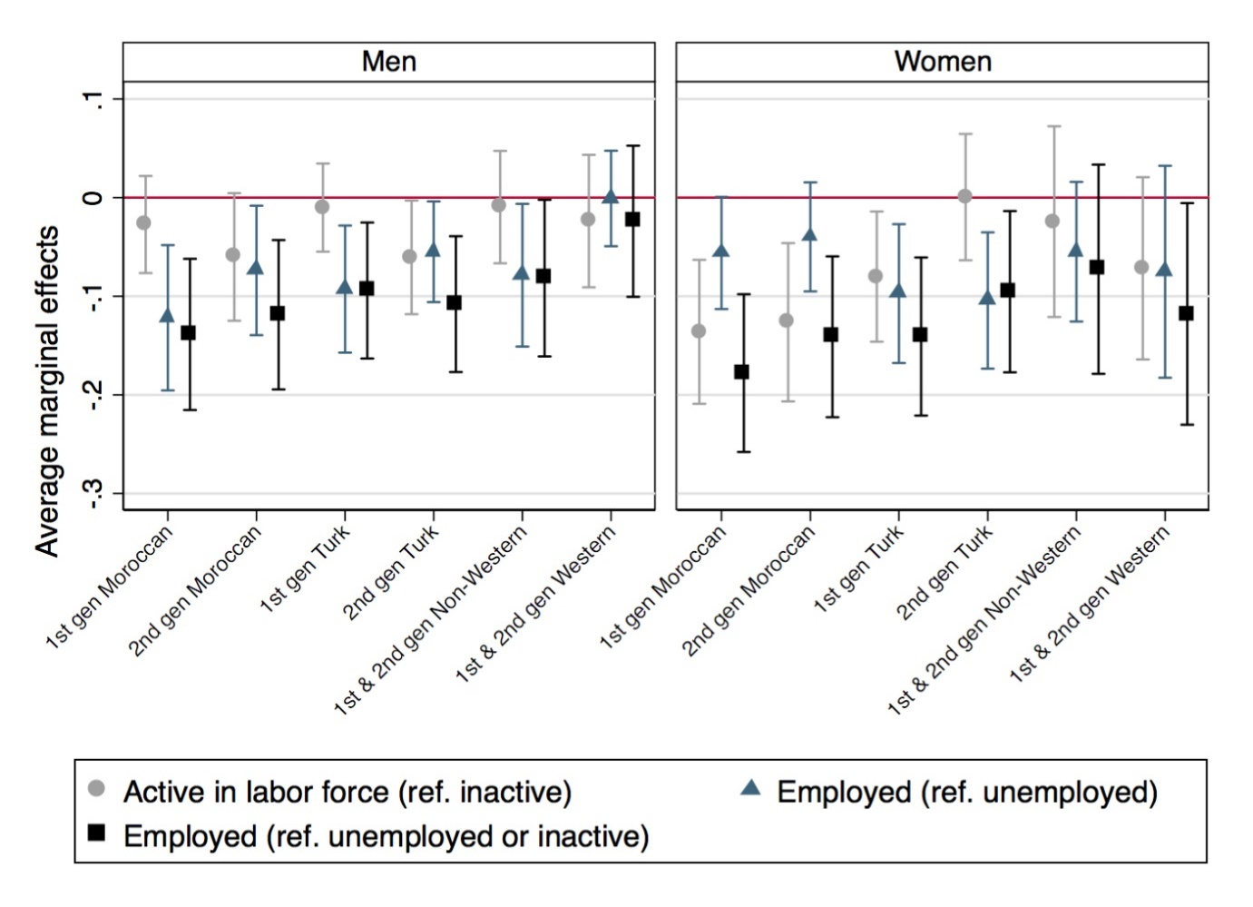
Figure A1: Gaps in labor market outcomes by ethnicity and generation. Models are weighted and account for age, age square, years of education, urbanity, region, cohabitation, presence of children in the household, language problems, and Dutch citizenship (see Table A4).
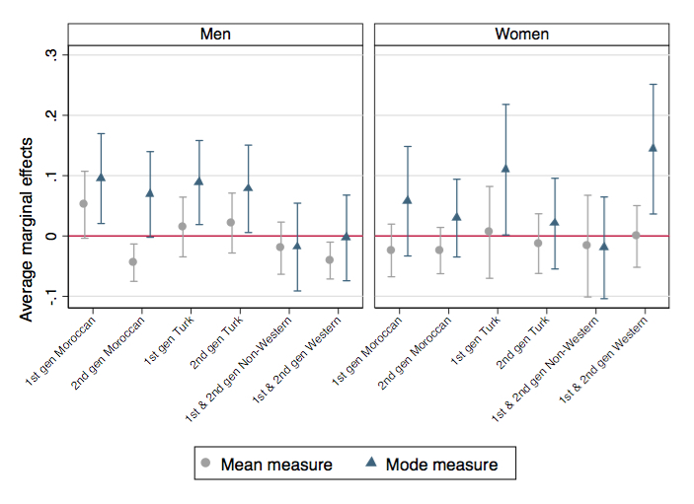
Figure A2: Estimated gap in overeducation between different origin groups and native Dutch majority after accounting additional for work experience. Models are weighted and account for age, age square, years of education, urbanity, region, cohabitation, presence of children in the household, language problems, Dutch citizenship and work experience in the Dutch labor market.
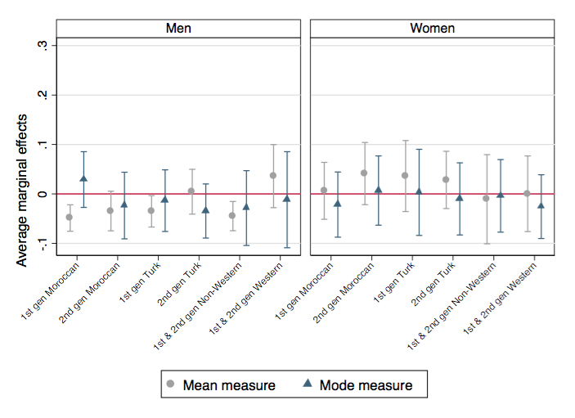
Figure A3: Estimated gap in undereducation between different origin groups and native Dutch majority after accounting additional for work experience. Models are weighted and account for age, age square, years of education, urbanity, region, cohabitation, presence of children in the household, language problems, Dutch citizenship and work experience in the Dutch labor market.

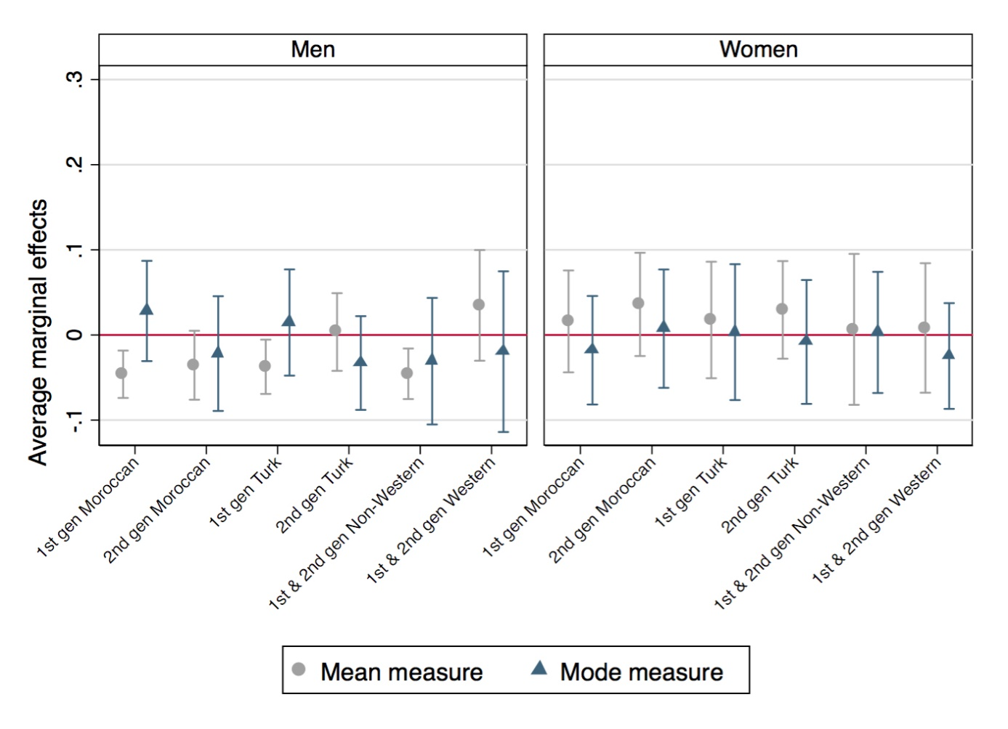
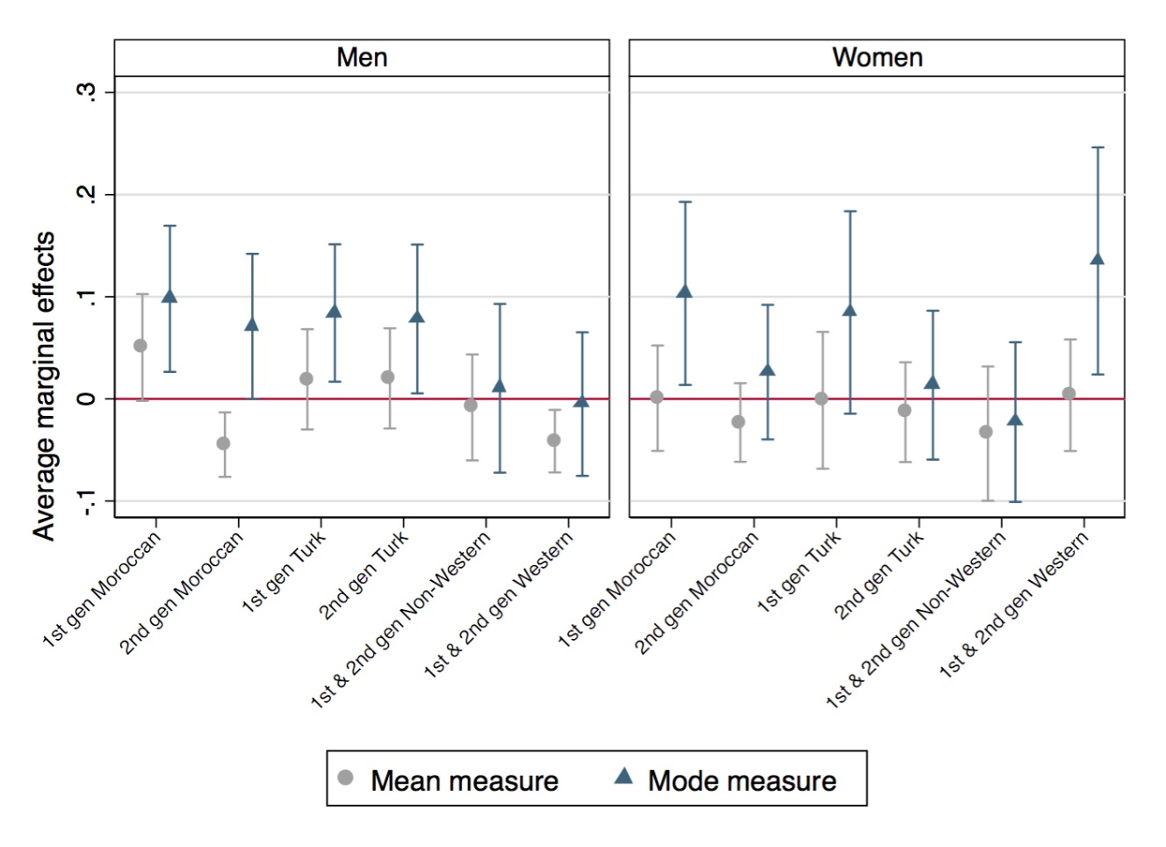
Figure A4: Estimated gaps in overeducation between different origin groups and native Dutch majority. Models are weighted and account for age, age square, years of education, urbanity, region, cohabitation, presence of children in the household, language problems, and Dutch citizenship (see Table A2). Values above zero indicate that the respective origin group is more likely to be overeducated than the native Dutch majority.
Figure A5: Estimated gap in undereducation between different origin groups and native Dutch majority. Models are weighted and account for age, age square, years of education, urbanity, region, cohabitation, presence of children in the household, language problems, and Dutch citizenship (see Table A4). Values above zero indicate that the respective origin group is more likely to be undereducated than the native Dutch majority.
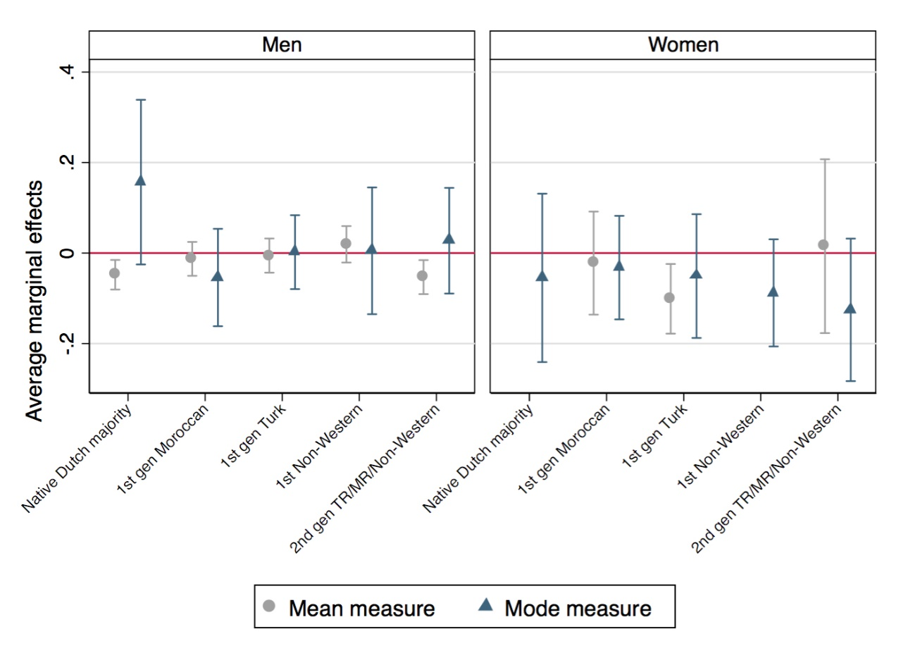
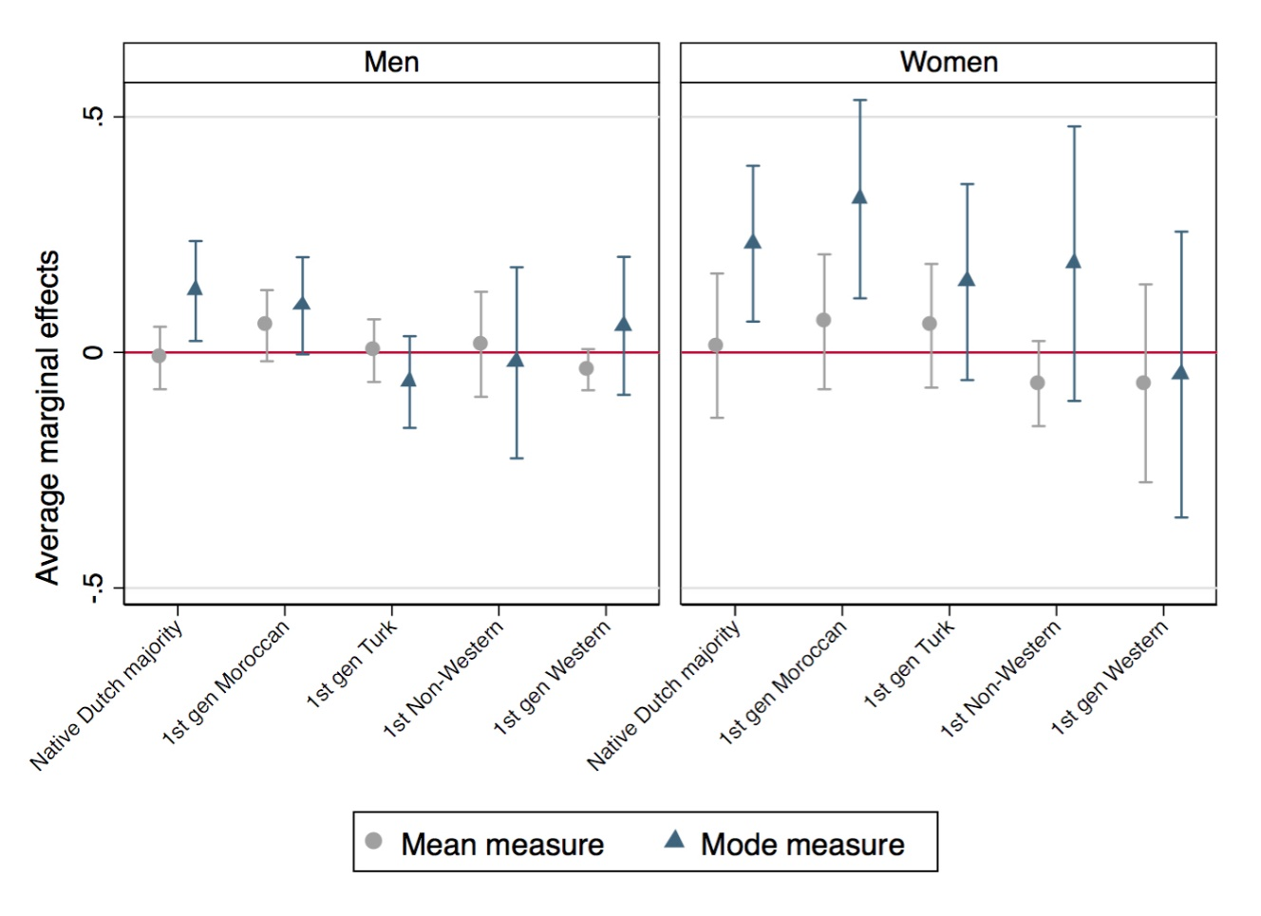
Figure A6: Average marginal effects of highest education received abroad (compared to highest education received in the Netherlands) on overeducation by origin and gender. Models are weighted and account for age, age square, years of education, urbanity, region, cohabitation, presence of children in the household, language problems, Dutch citizenship and an interaction of education received abroad (ref. education received in the Netherlands) with national origin.

Figure A7: Average marginal effects of highest education received abroad (compared to highest education received in the Netherlands) on undereducation by origin and gender. Models are weighted and account for age, age square, years of education, urbanity, region, cohabitation, presence of children in the household, language problems, Dutch citizenship and an interaction of education received abroad (ref. education received in the Netherlands) with national origin. Coefficient estimates for the native Dutch majority and 1st generation Non-Western immigrant women missing due to small sample sizes.
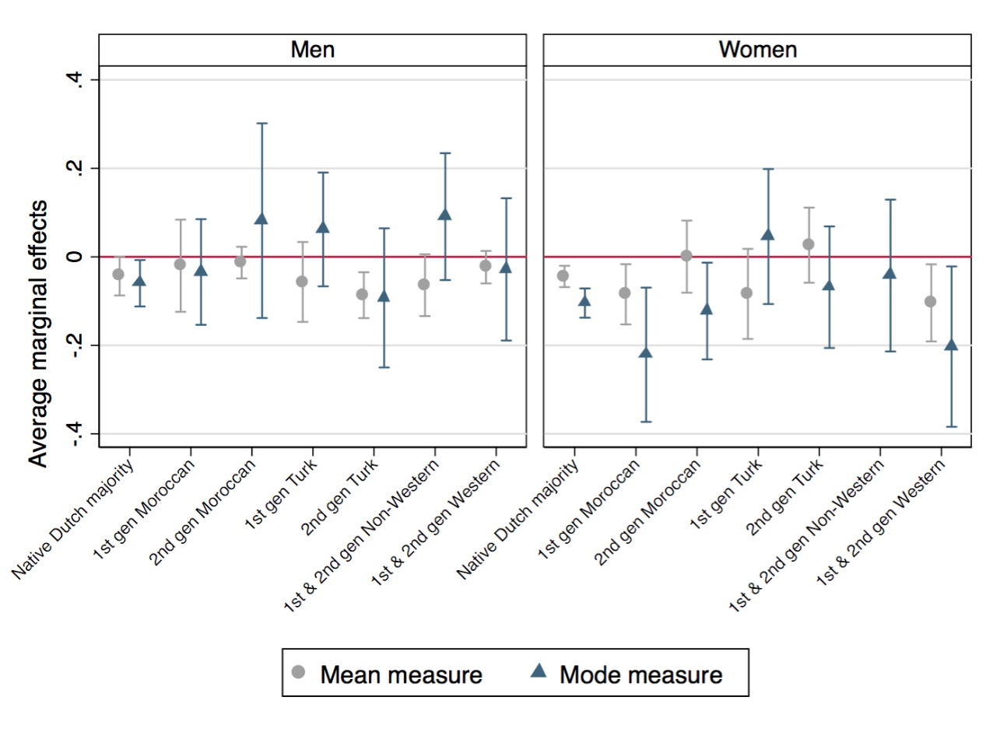
Figure A8: Average marginal effects of working in the public sector (compared to working in the private sector) on overeducation by origin. Models are weighted and account for age, age square, years of education, urbanity, region, cohabitation, presence of children in the household, language problems, Dutch citizenship and an interaction of public sector occupation (ref. private sector) with national origin.
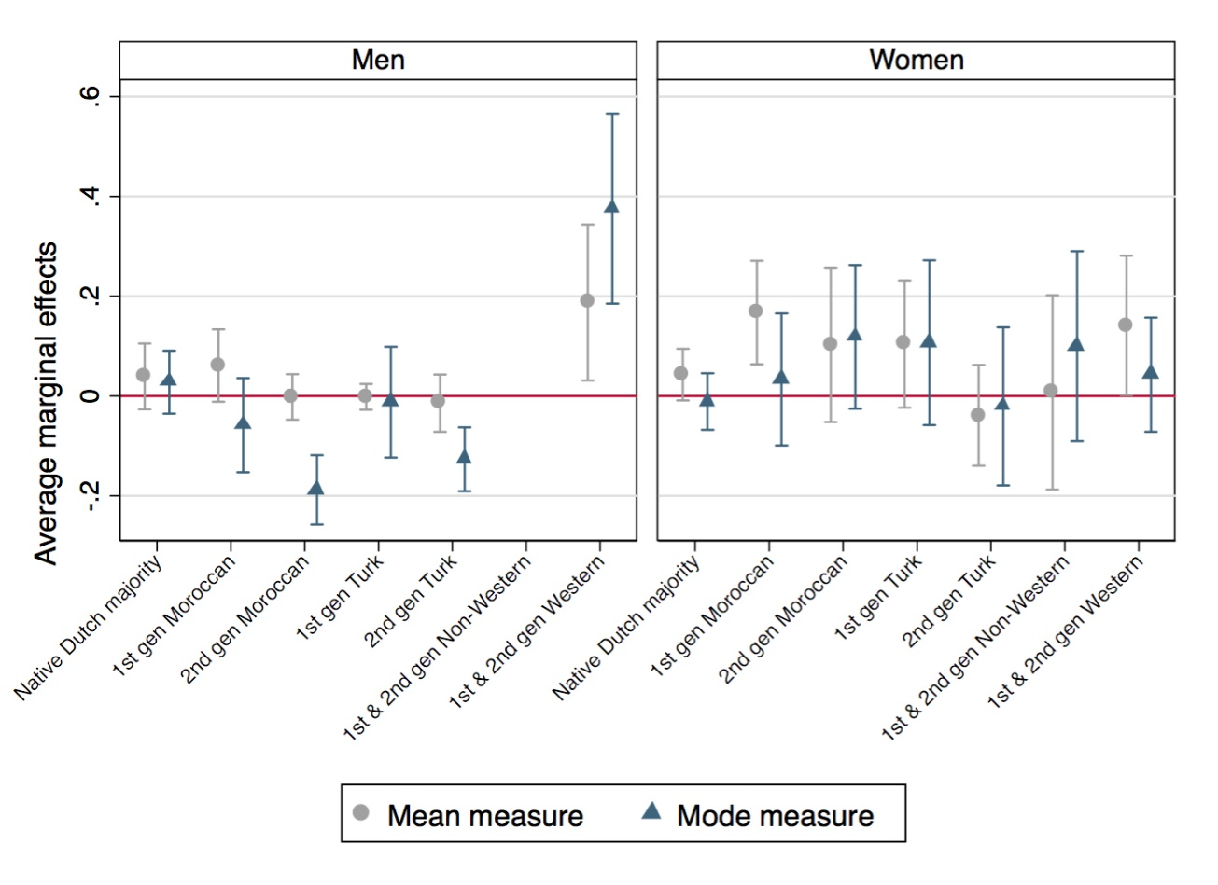
Figure A9: Average marginal effects of working in the public sector (compared to working in the private sector) on undereducation by origin. Models are weighted and account for age, age square, years of education, urbanity, region, cohabitation, presence of children in the household, language problems, Dutch citizenship and an interaction of public sector occupation (ref. private sector) with national origin. Coefficient estimates for 1st and 2nd generation Non-Western men missing due to small sample size.

