Appendix: Decomposition of the Maximal Fit

Definitions HP_{max}= Maximal House Performance
HP₁ = House Performance at moment 1
I_{max}= Maximal Importance
I₁ = Maximal Importance at moment 1
Maximal Fit = HP_{max}* I_{max}
= HP_{max}* I_{max} - HP_{max}* I₁ + HP_{max}* I₁
= HP_{max}*(I_{max} - I₁) + HP_{max}* I₁
= HP_{max}*(I_{max} - I₁) + HP_{max}* I₁ - HP₁* I₁ + HP₁ * I₁
= HP_{max}*(I_{max} - I₁) + (HP_{max} - HP₁)* I₁ + HP₁ * I₁
= HP₁ * I₁ + (HP_{max} - HP₁)* I₁ + HP_{max}*(I_{max} - I₁) (5)
HP₁ * I₁ is the Comfort Fit
(HP_{max} - HP₁)* I₁ is the Improvement Potential by changing the house, assuming that the importance of the indicator remains the same for the person.
HP_{max}*(I_{max} - I₁) can be interpreted as an Improvement Potential due to increasing Importance, after/during the architectural improvement of the dwelling.
Simply written it would look as follows:
Maximal Fit = Comfort Fit₁ + IP_{house} + IP_{person} (6)
From equations (1) and (6) we can say that:
Comfort Fit₁ = HP₁ * I₁
Comfort Fit₁ + IP_{person} = Maximal Fit - IP_{house}
Therefore:
(HP₁ * I₁ + HP_{max}*(I_{max} - I₁)) = Maximal Fit – (HP_{max} - HP₁)* I₁
This change of importance of an indicator (people’s values) during the renovation process, if it occurs, is psychological than architectural in nature. Therefore, it is not visualized in the Comfort Tool, and the Importance per indicator is considered to remain constant for the user before and after improvement. Since the improvement potential of the house is in fact a key element in the Comfort Profile and the Importance is considered to remain constant, the calculation implemented for the online tool can be simplified as follows:
Comfort Fit^{ext} = Maximal Fit – IP (7)
When using a Likert scale of 1-5 (as we do in the Comfort Tool) then HP_{max} is set to 5 and equation (2) shows the Maximal Fit value is set to 25. Therefore:
Comfort Fit^{ext} = 25 - (5 - HP₁) * I₁

Appendix 2: Comfort Tool Questionnaires

Comfort preferences (Importance) question:
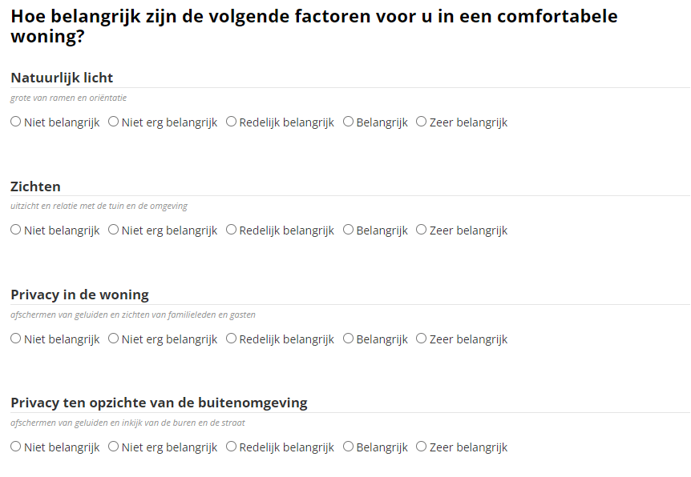

Home performance question:

