Supplementary documents:

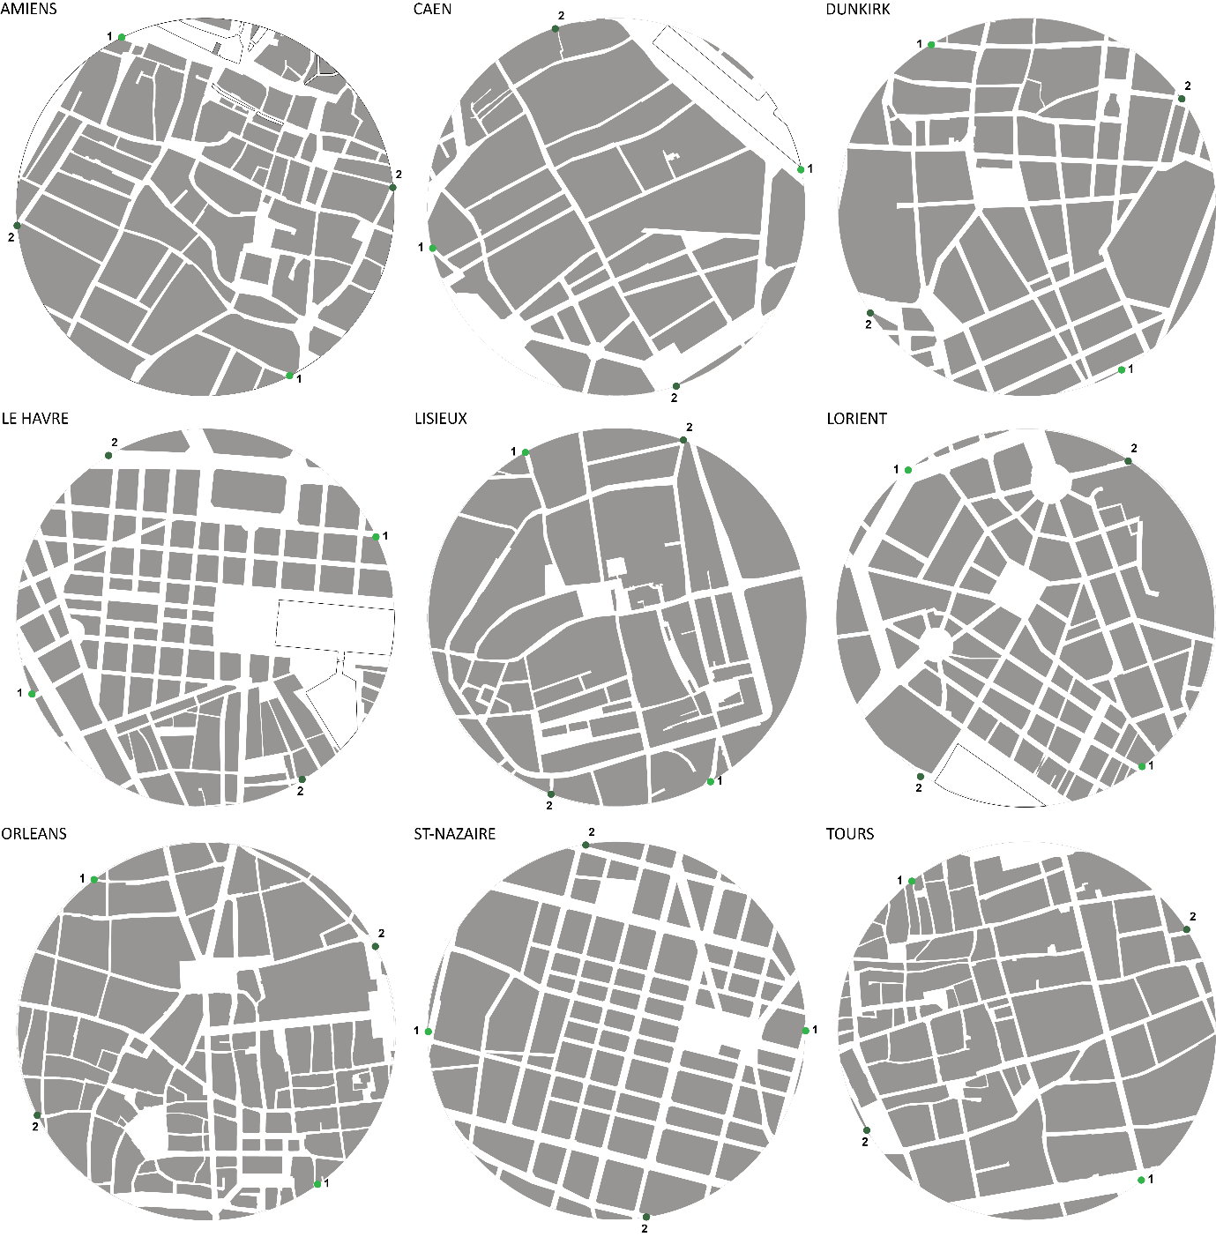

Figure i. Urban block maps representing the pre-war layouts used for the navigation task and the calculation of syntactic intelligibility.
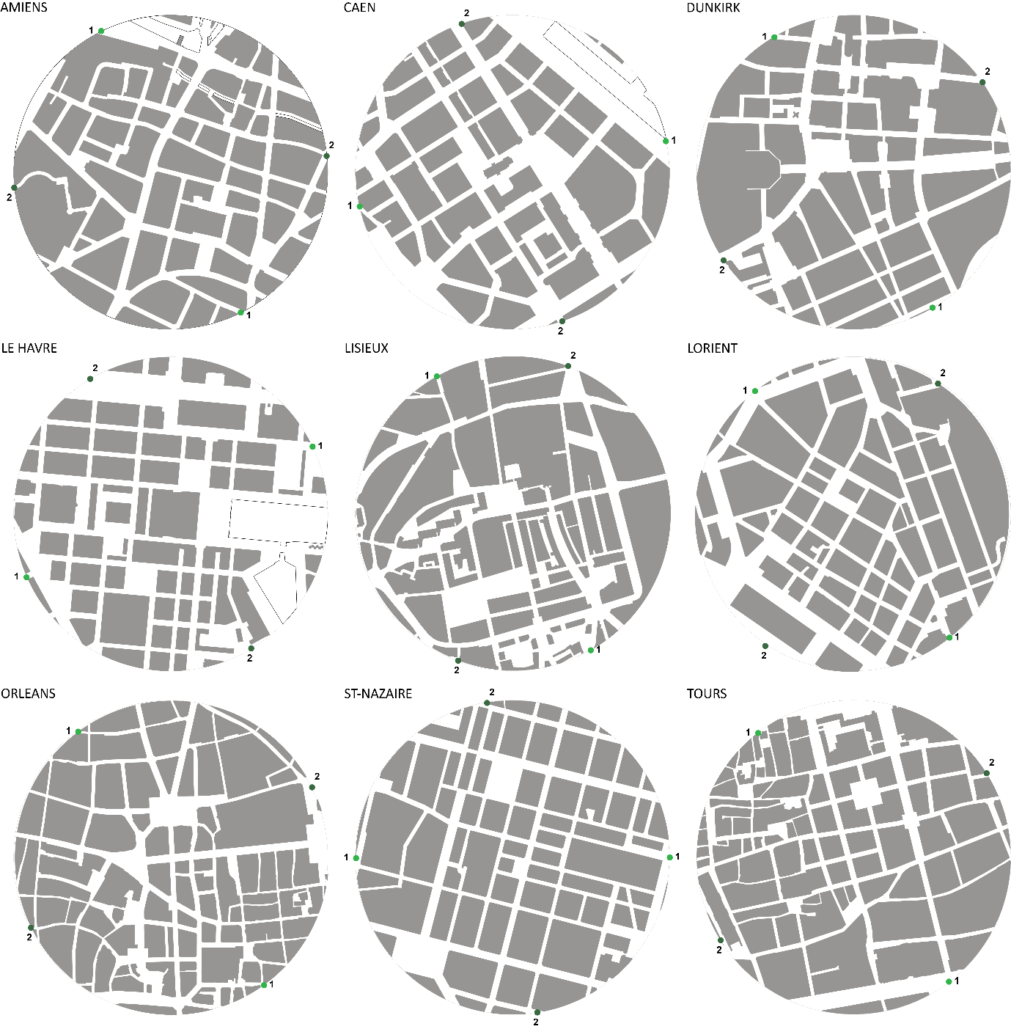

Figure ii. Urban block maps representing the post-war layouts used for the navigation task and the calculation of syntactic intelligibility.

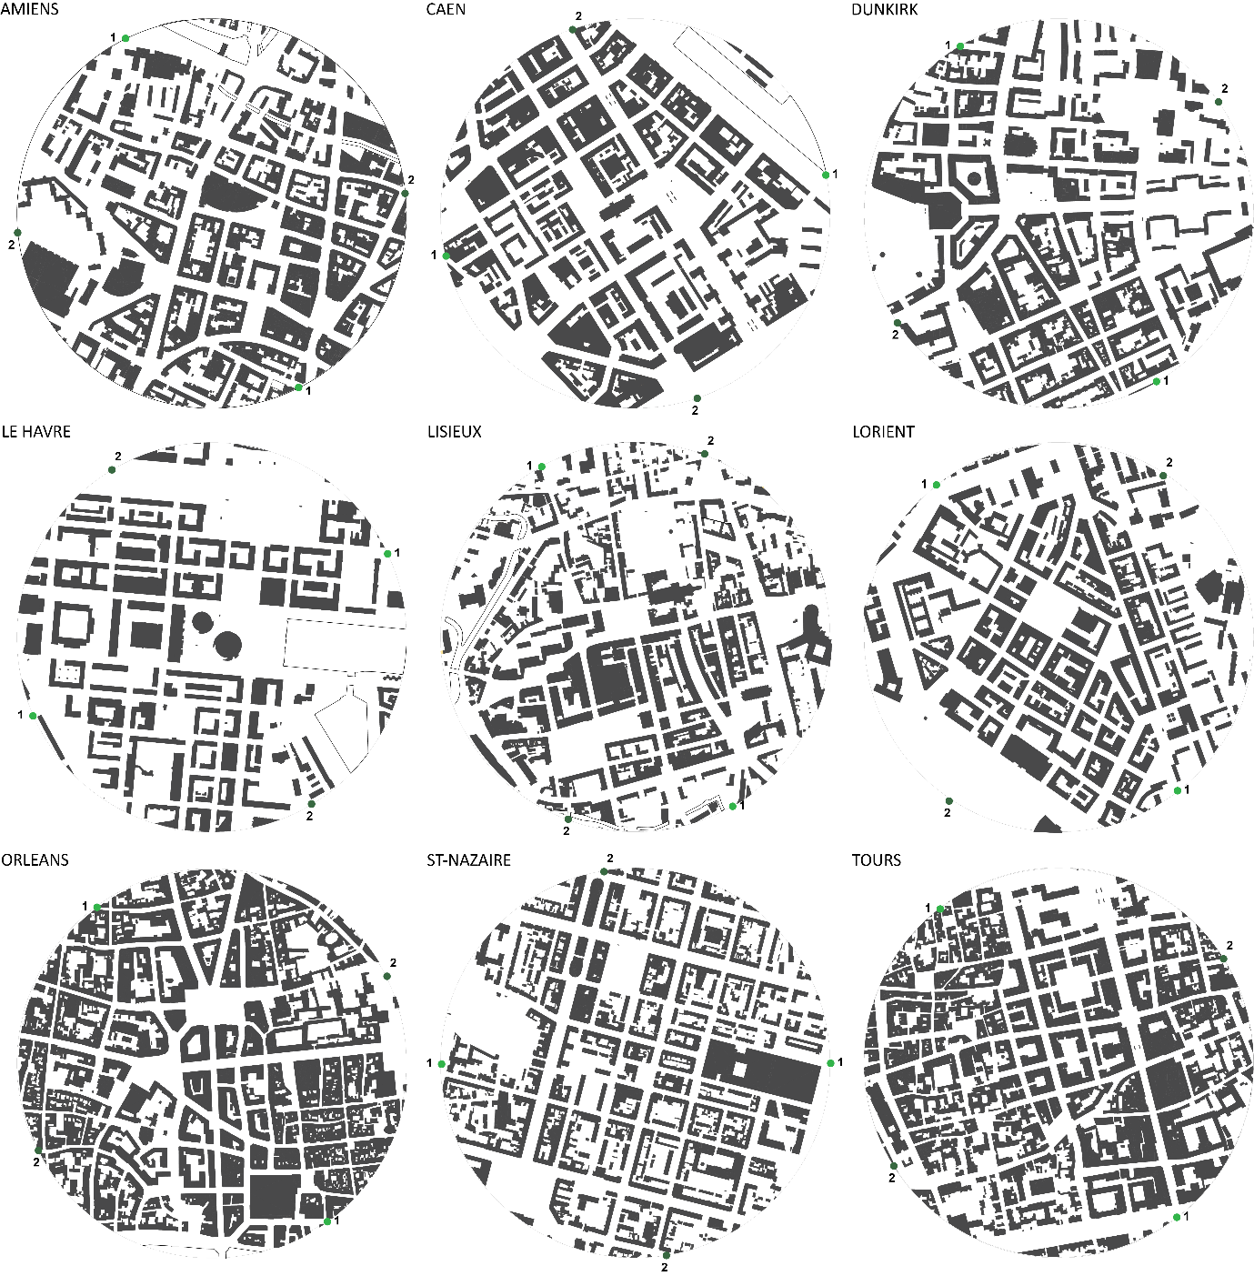
Figure iii. Building block maps representing the post-war layouts used for the navigation task and the calculation of syntactic intelligibility.

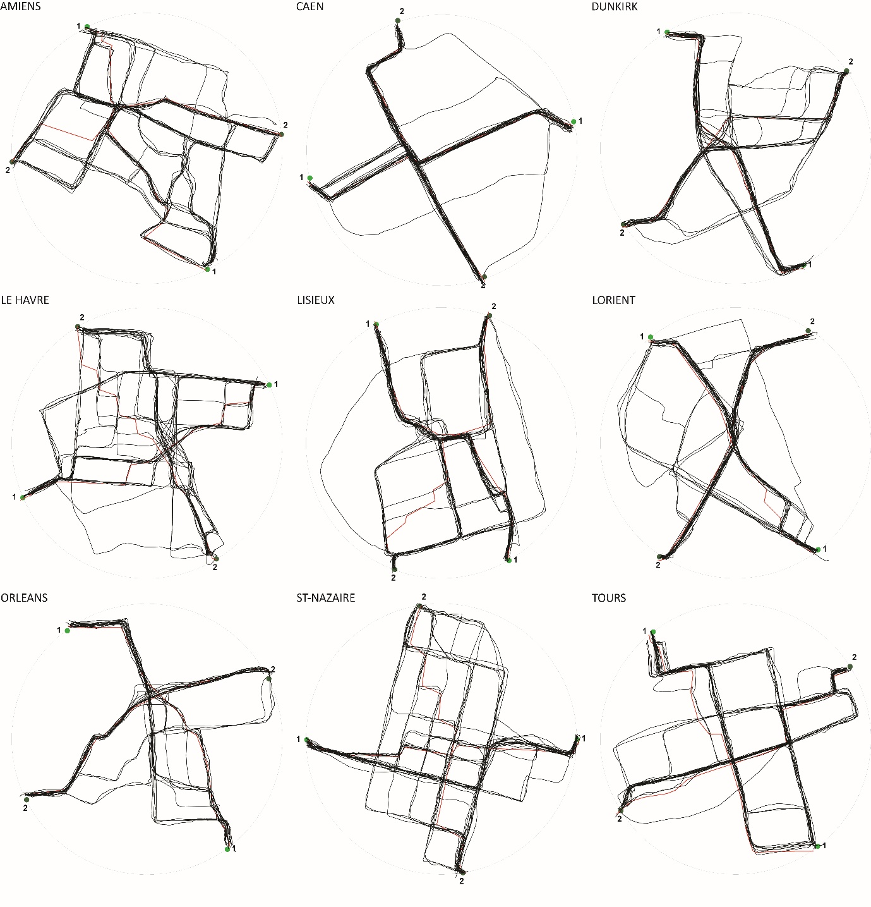
Figure iv. Routes drawn by participants on the pre-war block maps, the metric shortest path is indicated in red.

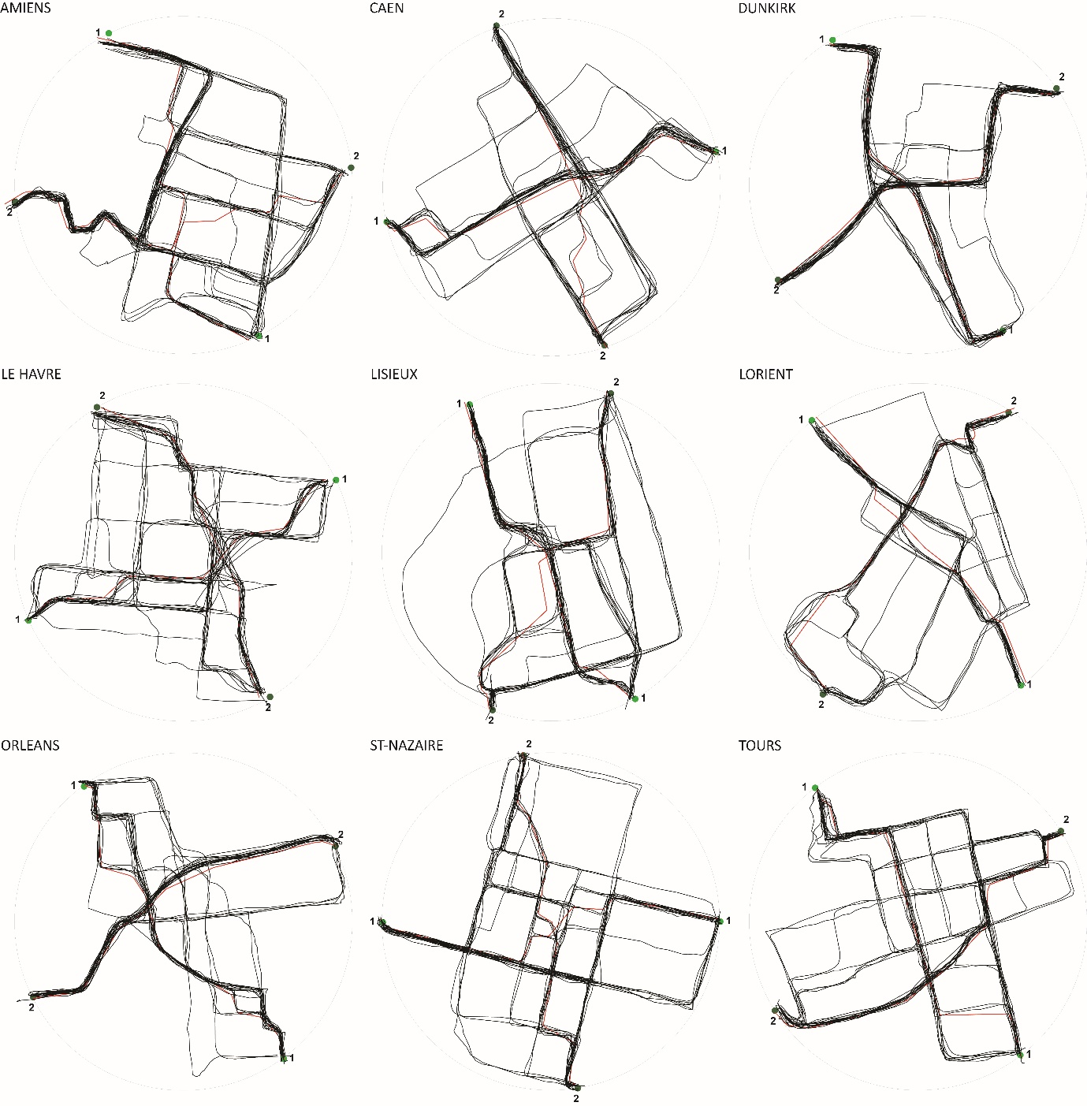
Figure v. Routes drawn by participants on the post-war block maps, the metric shortest path is indicated in red.
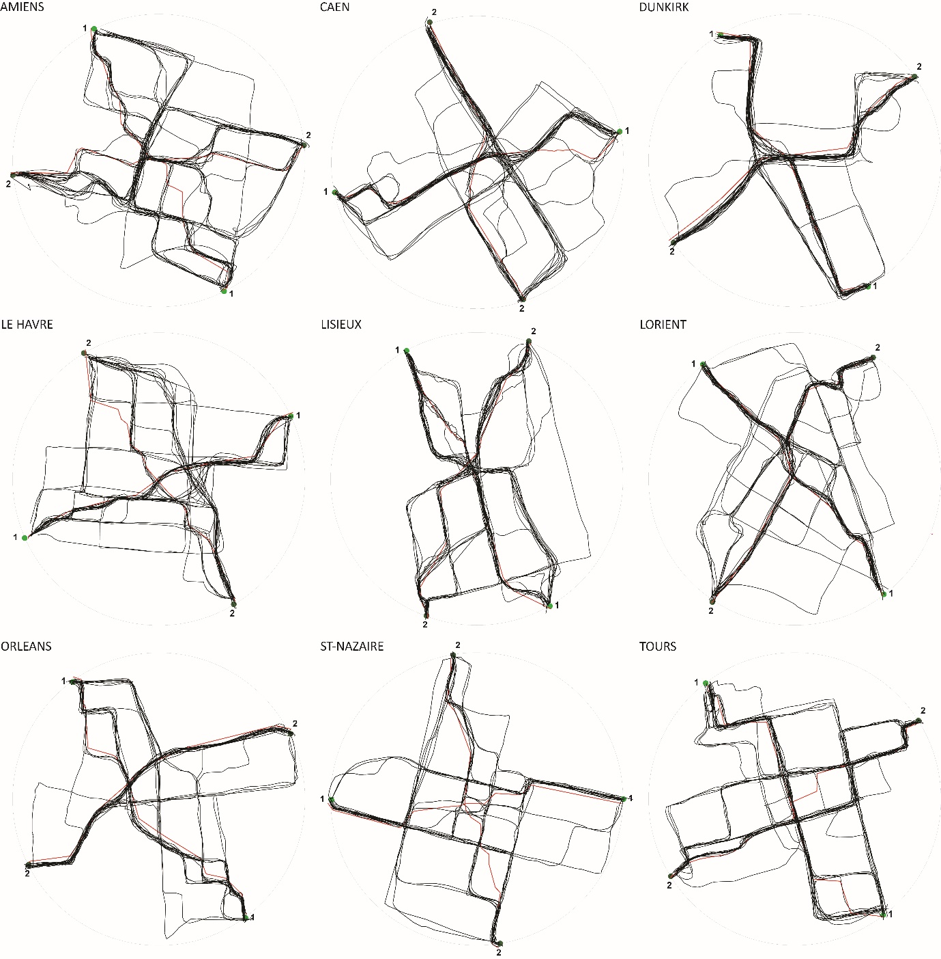
Figure vi. Routes drawn by participants on the post-war building maps, the metric shortest path is indicated in red.

