Supplementary Material
Table 4. Response rates of age-gender-groups.
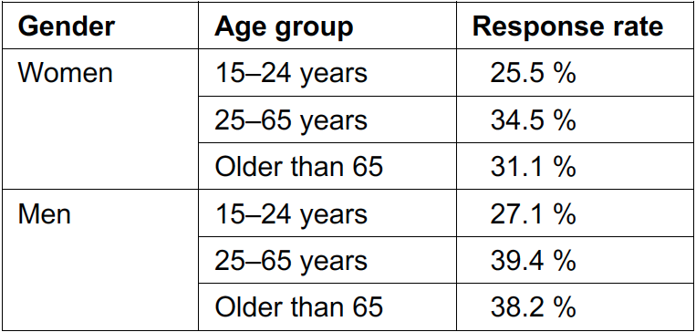
Table 5. Frequency distribution of all variables used in the logistic regression models.

